Name_______________________ Unit 10: I Can Statements Kinetics and EQ If you can do all the things listed below, you are ready for the Unit 12 test.
Place a checkmark next to each item that you can do! If a sample problem is given, complete it as evidence.
_____1. I can define effective collision and collision theory | Definition:  effective collision  collision theory
_____2. I can state and apply the relationship between temperature and reaction rate in terms of collision theory. | As the temperature ________________________, the reaction rate for most  chemical reactions _________________________ because there are _______  effective collisions between particles.  Given the reaction:  2Mg(s) + O2(g) -----> 2MgO(s)  At which temperature would the reaction occur at the greatest rate?  A) 0oC B) 15oC C) 95oC D) 273K
_____3. I can state and apply the relationship between surface area and reaction rate in terms of collision theory. | As the surface area ________________________, the reaction rate  ______________________________ because there are ____________ effective collisions between particles.  At STP, which 4.0 g sample of Zn(s) will react most quickly with dilute hydrochloric acid?  A) lump B) bar C) powdered D) sheet metal
_____4. I can state and apply the relationship between concentration and reaction rate in terms of collision theory. | As the concentration ____________________, the reaction rate  ______________________________ because there are _________ effective collisions between particles.  At 20oC, a reaction between powdered Zn(s) and hydrochloric acid will occur most quickly if the concentration of the HCl is  A) 1.0 M B) 1.5 M C) 2.5 M D) 2.8 M
_____5. Based on the location of the energy term, I can determine if the reaction is exothermic or endothermic. | Given the following balanced equation:  I + I -----> I2 + 146.3 kJ  Is this reaction exothermic or endothermic? Justify your answer.
_____6. I can use Table I to determine if a reaction is exothermic or endothermic. | 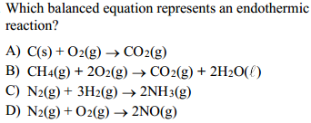
_____7. I can define potential energy diagram, reaction coordinate, PEreactant, PEproduct, heat of reaction (ΔH), activation energy, catalyst. | potential energy diagram  reaction coordinate  PEreactant  PEproduct  heat of reaction (ΔH)  activation energy  catalyst  entropy
_____8. Given a potential energy diagram, I can determine if the reaction is exothermic or endothermic. | Give the potential energy diagram below, determine if the reaction is exothermic or endothermic. Justify your answer.  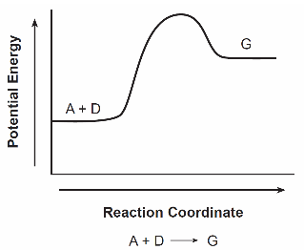
_____9. Given a potential energy diagram, I can determine the PEreactant, PEproduct, ΔH, and activation energy. | Given the potential energy diagram below, determine the PEreactant, PEproduct, ΔH, and the activation energy.  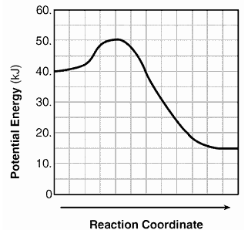  PEreactant = PEproduct =  ΔH = activation energy =
_____10. Given a potential energy diagram for an uncatalyzed reaction diagram, I can how the diagram will change when a catalyst is been added. | Draw a dotted line on the potential energy diagram shown below to indicate how it will change if a catalyst is added.  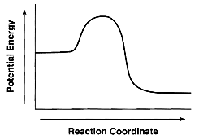
_____11. I can rank the three phases of matter from least entropy to most entropy. | Least entropy Most entropy  ______________________<______________________<__________________
_____12. I can state the trends in nature for entropy and energy. | In nature most systems in nature tend to undergo reactions that have a(n)  _______________________ in entropy and a(n) _________________________ in energy. nature is like a teenager ---- lazy and messy!
_____13. Given a balanced equation, I can determine if the reaction results in an overall increase or decrease in entropy. | 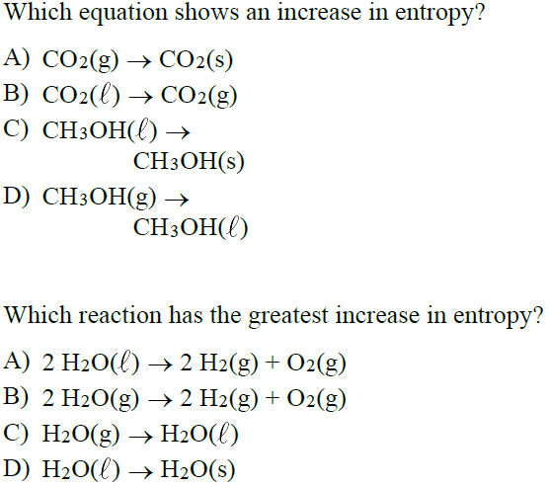
_____14. I can define forward reaction, reverse reaction, reversible reaction, and closed system | Definitions:  forward reaction  reverse reaction  reversible reaction  closed system
_____15. I can state the three types of equilibrium. | The three types of equilibrium are:  _______________________________ equilibrium  _______________________________ equilibrium and  _______________________________ equilibrium
_____16. I can state two conditions that apply to all systems at equilibrium. | In a system at equilibrium the ____________________ of the forward and reverse reaction must be ______________________ and the ________________________________ of the reactants and products must be _____________________.
_____17. Given a list of reactions, I can identify reactions that show equilibrium (chemical, phase, or solution). | Which balanced equation represents phase equilibrium?  A) H2(g) + I2(s) <-----> 2HI(g)  B) I2(s) <-----> I2(g)  H2O  Which balanced equation represents solution equilibrium?  A) H2(g) + I2(s) <-----> 2HI(g)  B) I2(s) <-----> I2(g)  H2O  C) KCl(s) <-----> KCl(aq)  D) 2KCl(s) + 3O2(g) -----> 2KClO3  Which balanced equation represents chemical equilibrium?  A) H2(g) + I2(s) <-----> 2HI(g)  B) I2(s) <-----> I2(g)  H2O  C) KCl(s) <-----> KCl(aq)  D) 2KCl(s) + 3O2(g) -----> 2KClO3
_____18. In terms of saturation, I can describe a solution that is at equilibrium. | In terms of saturation, a solution that is at equilibrium must be  ____________________________.
_____19. I can state LeChatelier’s Principle. | LeChatelier’s Principle states
_____20. Given a balanced equation at equilibrium, I can predict the direction of shift in the equilibrium when the temperature, concentration, or pressure is changed or if a catalyst is added. | Given the reaction at equilibrium:  2SO2(g) + O2(g) <-----> 2SO3(g) + 392kJ  Predict the direction of shift in the equilibrium (right, left, no shift) when the following changes are made to the system.  Change Direction of Shift  Increase concentration of SO2  Increase concentration of SO3  Increase temperature  Increase pressure  Add a catalyst

