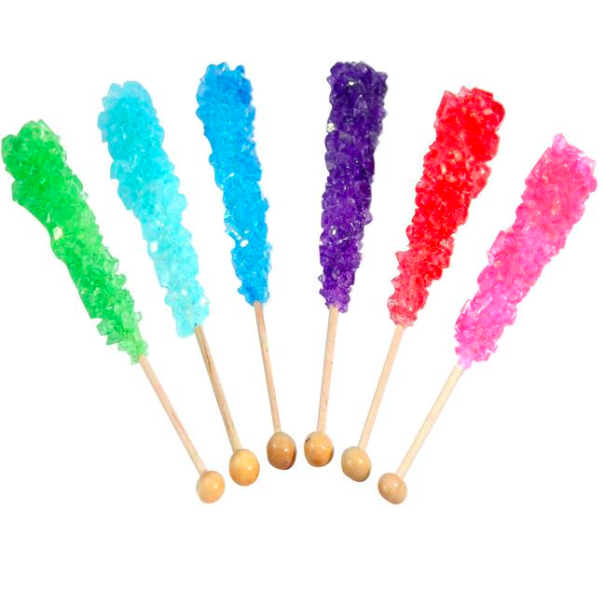
SUPERSATURATED SOLUTIONS:
ROCK CANDY EXTRA CREDIT LAB
Purpose:
To introduce crystal growth in order to demonstrate the properties of supersaturated solutions

Information:
Solubility of substances improves with stirring (mechanical energy) and by heating (heat energy). You will find that the solvent dissolves only so much solute. After a while, the excess solute precipitates to the bottom. When this happens, the liquid is a saturated solution.

Solutes dissolve in larger quantities when placed into heated liquids (solvents) because the molecules of the heated liquids vibrate further apart. The spaces between the molecules become greater and more solid molecules (sugar) can fill these spaces. As the liquid cools down, the spaces between the molecules become smaller and the excess solids precipitate to the bottom.

Heating solvents to dissolve additional solute. Once the solution cools, it now has more solute than it normally could have, and this is called a supersaturated solution. Once a solution becomes supersaturated, it wants to crystallize the excess solute. The solute will form crystals on any surface. In our case the surface is a string, and we are using a lifesaver candy as our “seed.” A seed is a starting point, a solid piece of sugar candy will mimic a sugar crystal, and start the chain reaction of crystallization. If the jar is left uncovered, crystals may even form on the dust that settles on top.

Equipment:
1 Glass jar, piece of cotton string, pencil or stick, paper clip, food coloring, 1 cup of water, 2 cups of sugar

Procedure:
- Tie a short piece of cotton string to the middle of a pencil or stick
- Attach a paperclip to the end of the string for a weight
- Moisten the string very lightly and roll a bit of sugar onto the string
- Place the pencil or stick over the tope of the glass with the string and paper clip down
- Heat the water to a boil in a saucepan and dissolve 2 cups of sugar into it
- Add a few drops of food coloring if desired
- Pour the solution into the prepared glass or jar and leave undisturbed for a couple of days. Resist the urge to touch or move the crystals while they are growing.
You should see crystals growing within a few days!

For extra credit, complete question 7, 8 and conclusion and bring in your crystals or take a picture of yourself with them!

Discussion Questions:

- What is the difference between an unsaturated, saturated and a supersaturated solution?

- What was the solute in the lab? The solvent?

- Why is it necessary to heat a solvent in order to make a supersaturated solution?

- Describe a point in the lab where each of the following happened…
  - had an unsaturated solution

  - had a saturated solution

  - had a supersaturated solution

- Why was it necessary to use a paperclip?

- Sugar dissolves easily in water. Since “like dissolves like”, what does sugar’s solubility in water tell you about the properties of sugar molecules?

EXTRA CREDIT BEYOND THIS POINT!!!!

- Besides increasing the temperature of the water, describe two ways you could get sugar to dissolve in water faster.

- You dissolved 450.0 g of sugar (C12H22O11) in 150 mL of water. The density of water is 1.00 g/mL
  - Calculate the molarity of the solution

  - Calculate the molality of the solution

Conclusion:

A: Describe how you created a supersaturated solution and how you formed sugar crystals.

B: Describe The general shape of the crystals (were they round, jagged, smooth etc), and how does it compare to the sugar you started with. How successful were you at creating rock candy? Did you make a lot, a little?

C: Describe any problems you had with the crystals. Did any crystals form on places other than the string? Was any stuck to the jar? Explain how you think these problems could be avoided. If you had the perfect crystal, then explain why you think yours turned out so much better and explain how you think you can make even larger crystals.

