Regents Chemistry Extra Review Packet for Midterm Exam 2015-2016
Name:
Atomic Structure
- What is the definition of each of the following terms:
  - Atomic number = number of protons

  - Mass number = number of proton plus number of neutrons

  - Isotope = two (or more) atoms of the same element with different # neutrons (so have different mass numbers) examples: ¹⁴₆C and ¹³₆C and ¹²₆C

  - Nucleon = term used to collectively indicate the protons and neutrons in the nucleus

- The number of electrons in a neutral atom is equal to the number of __protons____

- Complete the following table:
Atom | # of protons | # of neutrons | # of electrons | Atomic # | Mass #
¹²₆C | 6 | 6 | 6 | 6 | 12
⁷₃Li | 3 | 4 | 3 | 3 | 7
²³₁₁Na | 11 | 12 | 11 | 11 | 23
³₁H | 1 | 2 | 1 | 1 | 3
⁴₂He | 2 | 2 | 2 | 2 | 4

- Describe Rutherford’s famous experiment. What were the two results of the experiment and what conclusion did Rutherford draw from each result?
1. positively charged part of atom is very small and is located in the center of the atom
2. majority of the atom is empty space

- What is the difference between an isotope and an ion?

Isotopes are 2⁺ same atoms with different # neutrons
Ions are atoms that are charged due to losing/gaining electrons

- Given that chlorine is 75% Cl-35 and 25% Cl-37, calculate the average atomic mass of chlorine.

(.75)(35) + (.25)(37) = 35.5 amu
- What radioactive isotope is used to date organic material (wool, linen, wood, bones, etc)?

C-14

- What is the absolute temperature scale?
Kelvin
- In the Bohr model of the atom, describe the type of electron transition which will result in the production of a spectral line. Is this transition endothermic or exothermic?

electrons transitioning from higher energy levels to lower energy levels emit wavelengths of light (bright line spectra) - this is an exothermic process since energy is emitted

- How many atoms are represented in the formula (NH₄)₂SO₄?
2 atoms of N, 8 atoms of H, 1 atom of S, 4 atoms of O for a total of 15 atoms
- What are two common substances that sublime?

CO₂(s) [carbon dioxide] and I(s)
Periodic Table
- What is nuclear charge? What is effective nuclear charge?
- Nuclear charge is the charge of the nucleus = positive sign with # protons in nucleus
- example: nuclear charge of K is +19
- Effective nuclear charge: charge felt by valence electrons
  - Calculate: # protons minus # kernel electrons

- What is ionization energy?
amount of energy needed to remove the most loosely held electron (valence)from an atom
- What is electronegativity?
ability of an atom to hold onto its own electrons & attract its neighbor’s electrons

- What are the trends for atomic size, ionization energy, & electro negativity in the Periodic Table?
- Atomic size ↑ as go down a column from top to bottom and ↓ as go left to right across a row
- electro negativity increases from bottom left (Fr) to upper right (F)
- ionization energy ↓ as go down a column from top to bottom and ↑ as go left to right across a row

Intermolecular Forces
- What are the three IMF? Which force is weakest? Which force is strongest?
Dispersion (weakest), diploe-dipole, H-bonds (strongest)

- Describe the kind of molecule that exhibits each kind of intermolecular force (ex: polar, non-polar, etc)
Dispersion: monatomic elements, diatomic elements, non-polar molecules (symmetrical)
- Ca, Ni, H_{2,} O₂, CH₄, CO₂
Dipole-dipole: polar molecules (asymmetrical)
- CH₃Cl, HCl
H bonds: H bonded to F, O, N
- HF, H₂O, NH₃

- Why does water have a high boiling point? has H bonds (strongest IMF)

- What kind of IMF exists between each of the following molecules?

  - CH₄ ___dispersion____
  - HCl __dipole-dipole____
  - CH₃OH __ H bonds___
  - CO₂ ___ dispersion ___
  - Xe ___ dispersion ____
  - NH₃ ___H bonds__
  - He ___ dispersion ____
  - N₂ ____ dispersion ___
  - HF ___H bonds___

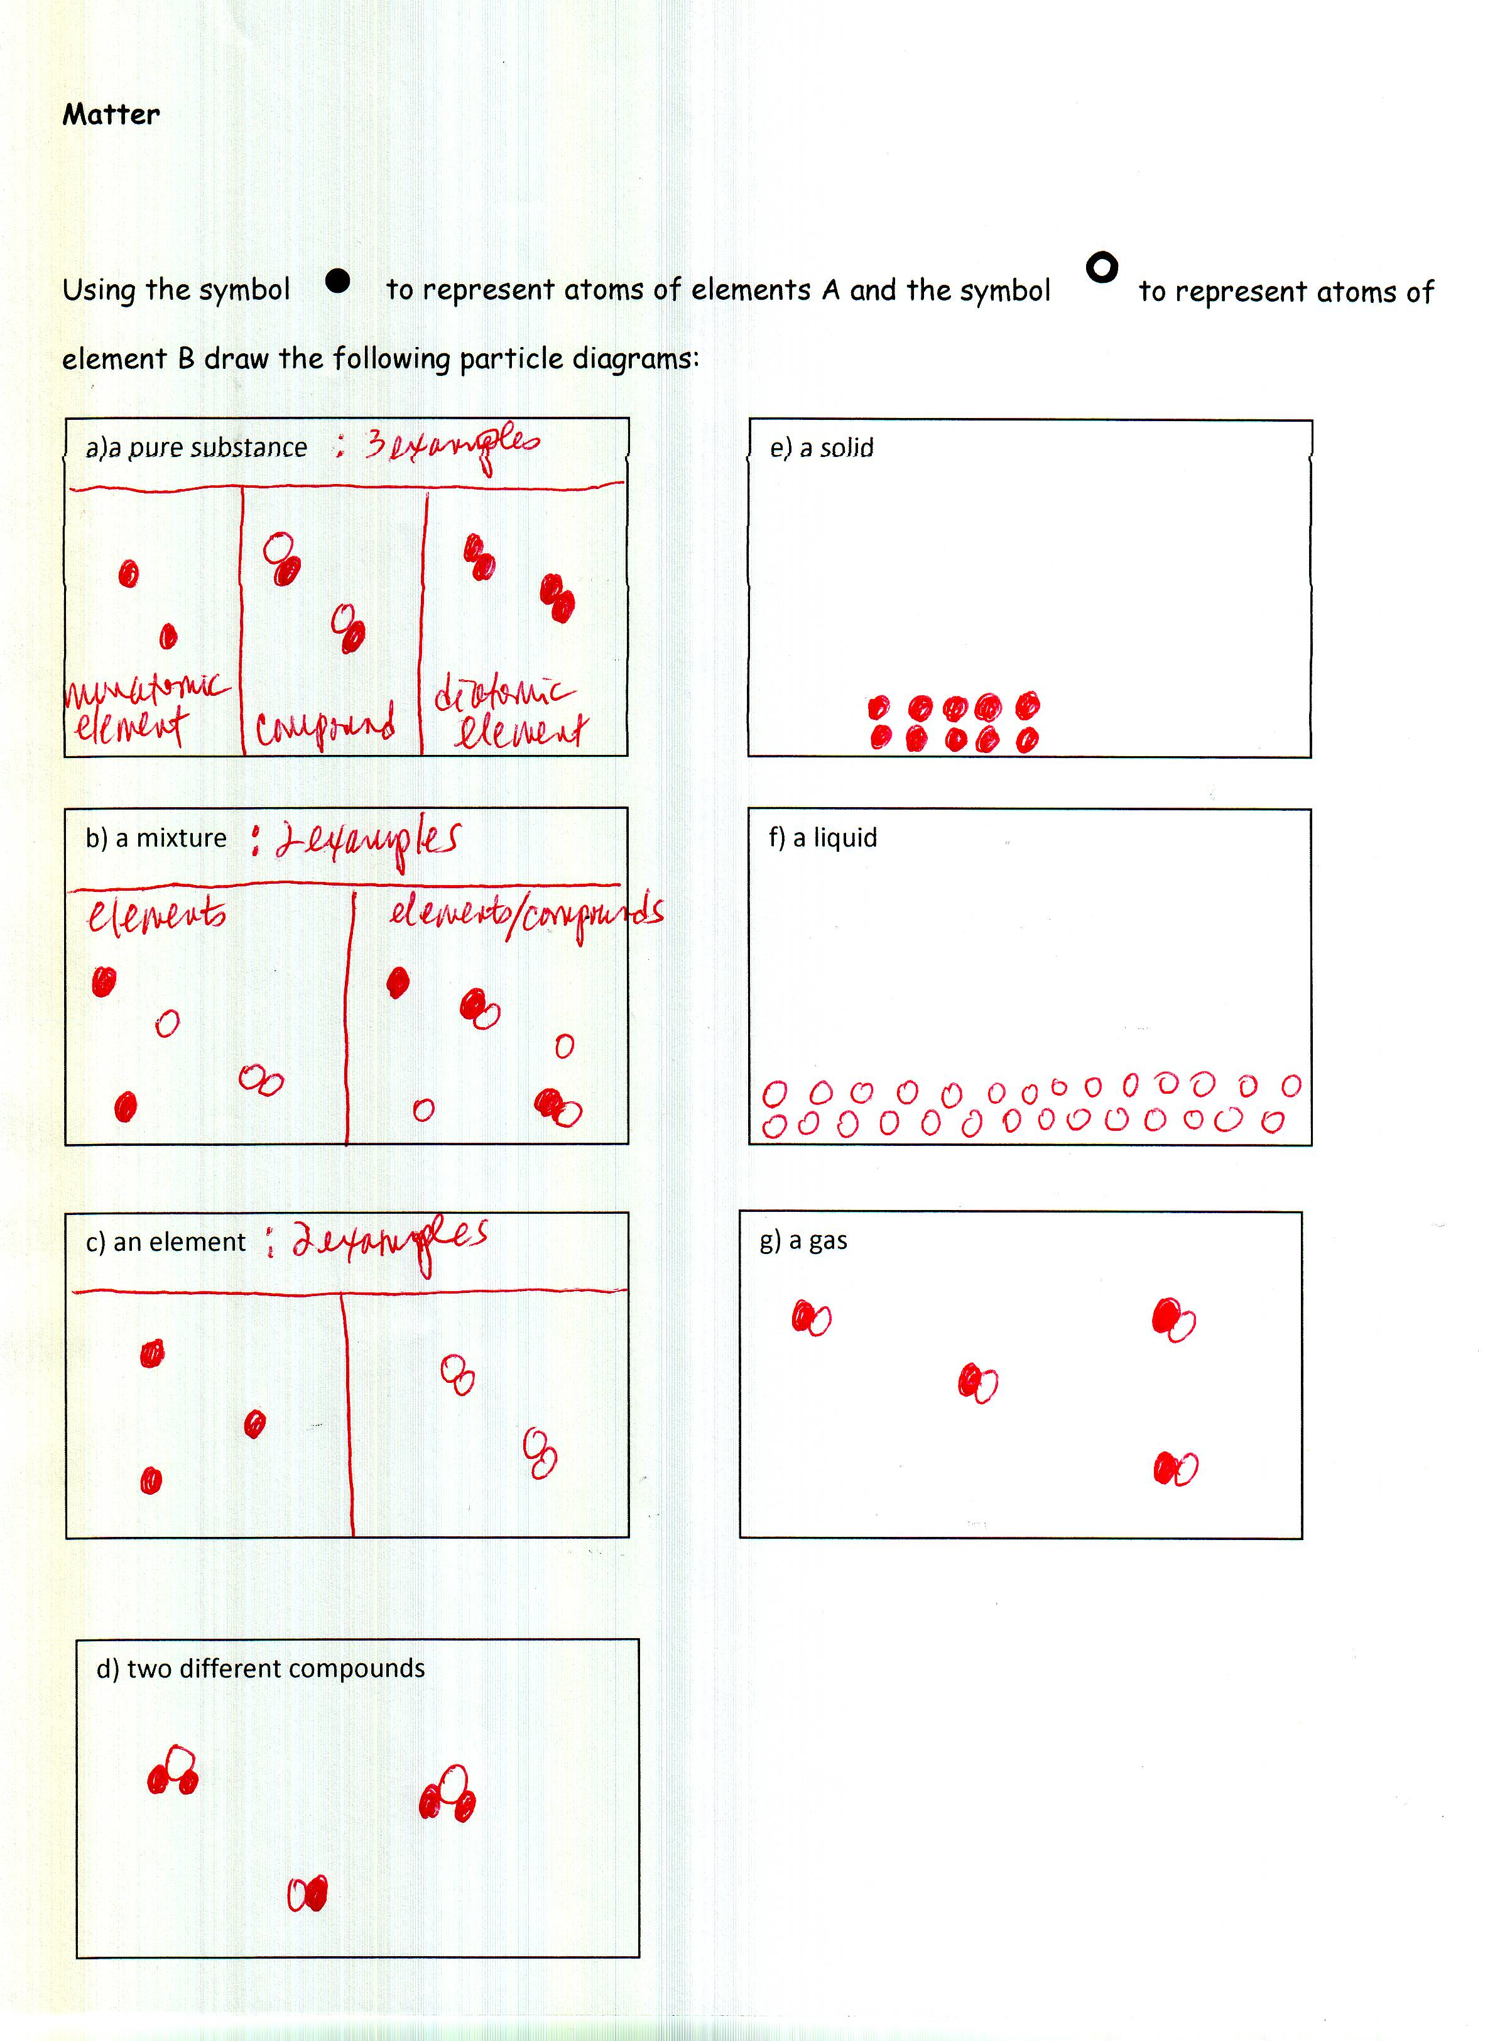
Energy Changes: Identify the Q equation needed to solve each of the following energy word problems below, then solve each problem.

- How much energy is required to heat a 35.0 g sample of water from 35ºC to 75ºC?
Equation:____Q = mcΔT_______

Q = (35.0g)(4.18J/gºC)(40 ºC) = 5,852 J

- An ice cube at 0˚C with a mass of 175.0g melts. How much energy does the ice absorb to melt?
Equation: ____Q = mH_{f}_____________

Q = (175.0g)(334J/g) = 58,450 J

- An 85.0g sample of water at 100.0˚C boils. How much energy is required to convert the water to steam at 100.0˚C?
Equation: ____ Q = mH_{v} ___________

Q = (85.0g)(2260J/g) = 192,100 J

- A sample of water with a mass of 160.0g is heated from 15.0˚C to 70.0˚C. How much energy is required to heat the water?
Equation: _____ Q = mcΔT ________

Q = (160.0g)( 4.18J/gºC)(55ºC) = 36,784 J

- 450.0g of water at 0.0˚C is frozen to ice at 0.0˚C. How much energy is released to the environment?
Equation: ______ Q = mH_{f} ________

Q = (450.0g)(334J/g) = 150,300 J

- 200.0g of steam at 100.0˚C condenses to water at 100.0˚C. How much energy is released to the environment?
Equation: ____ Q = mH_{v} ______
Q = (200.0g)(2260J/g) = 452,000 J

- A 225g sample of water is cooled from 95.0˚C to 40.0˚C. How much energy is released to the environment?
Equation: _____ Q = mcΔT ____

Q = (225g)(4.18J/gºC)(-55ºC) = (-) 51,727.5 J

- A block of ice at 0.0˚C with a mass of 1.0kg melts. How much energy is absorbed from the environment to convert it to water at 0.0˚C?
Equation: ____ Q = mH_{f}_________

Q = (1000g)(334J/g) = 334,000 J

- A 200.0g sample of water at 100.0˚C is boiled and converted to steam at 100.0˚C. How much energy is required?
Equation: _____ Q = mH_{v}_______

Q = (200.0g)(2260J/g) = 452,000 J

- If you carry out a reaction in a Styrofoam cup calorimeter and
  - the temperature of the water increases, is the reaction endothermic or exothermic?
  - the temperature of the water decreases, is the reaction endothermic or exothermic?
  - How would you calculate the energy change? Q = mcΔT

Phase Changes
boiling endothermic heat of fusion phase change condensation
evaporation heat of vaporization solid constant exothermic
increasing sublimation decreasing fusion liquid
temperature deposition gas melting vaporization

- _temperature_ is a measure of the average kinetic energy of the particles of a substance.

- _vaporization_ is another word for boiling.

- _heat of fusion_ is the amount of energy required to melt one gram of a solid at its melting point.
- _fusion__ is another word for melting.

- One type of physical change is a _phase change___.

- Solid to liquid or gas is an example of an _endothermic__ process.

- __evaporation__ is the spontaneous change from liquid to gas at any temperature.

- __sublimation__ is the change from solid phase to gas phase.

- The average kinetic energy of the particles of a substance is increasing when the temperature is ___increasing______.

- __gas__ takes the shape and volume of its container.

- __boiling__ is the change from liquid phase to gas phase at a constant temperature.

- __condensation_ is a change from gas to liquid phase which is noticeable on glass.

- __melting___ is the change from solid to liquid phase at a constant temperature.

- __heat of vaporization__ is the amount of energy required to convert one gram of a liquid to the gas phase at its boiling point.

- __deposition_ is the change from gas phase to the solid phase.

- __solid__ has a definite shape and a definite volume.

- Gas to liquid or solid is an example of an _exothermic__ process.

- When the temperature is constant, the average kinetic energy of the particles in a substance is ___constant____.

- __liquid__ has definite volume and indefinite shape.

- When temperature decreases, the average kinetic energy of the particles of a substance is __decreasing___.

