Name___________________________ Unit 12: Organic Chemistry Period________
_____12. I can define organic compound, saturated hydrocarbon, unsaturated hydrocarbon, and isomer. | Definitions:  organic compound  saturated hydrocarbon  unsaturated hydrocarbon  isomer
_____13. I can expand a condensed structural formula to show the structural formula of an organic compound. | Draw the complete structural formula for CH3CH2CH2CH2CH3.  Draw the complete structural formula for CH3CHCHCH3.
_____14. I can state the name and symbol of the element that is capable of forming rings, chains, and networks. | The element that is capable of forming rings, chains, and networks is  ______________________. Its symbol is_______________.
_____16. Given the formula, I can determine if a compound is a hydrocarbon or not. | 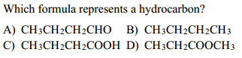
_____17. Given the name, I can use Reference Table P to determine how many carbons atoms are in a compound. | Determine how many carbon atoms are in each of the following compounds:  decane________________________ ethene___________________________  3-nonene______________________  1-pentyne__________________________
_____18. Given the name, I can use Reference Table Q to determine to which class of hydrocarbons a compound belongs. | Determine the homologous series of hydrocarbons to which each of the following belongs:  decane________________________  2-decene__________________________  1-pentyne__________________________
_____19. Given the name, I can determine if the hydrocarbon is saturated or unsaturated. | Determine if each of the following is a saturated or unsaturated hydrocarbon.  decane________________________ ethene___________________________  1-pentyne__________________________
_____20. Given the formula, I can determine to which homologous series a hydrocarbon belongs. | Determine the homologous series of hydrocarbons to which each of the following belongs:  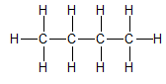belongs to the _______________________ series.  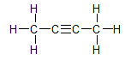belongs to the ________________________ series.
_____21. Given the formula, I can determine if a hydrocarbon is saturated or unsaturated. | Determine if each of the following is a saturated or unsaturated hydrocarbon.  C₂H₂ ___________ CH₃CH_{3 _____________} CH₃CH₂CH₂CH_{3 _________________}
_____23. Given a list of compounds, I can determine which ones are isomers. | 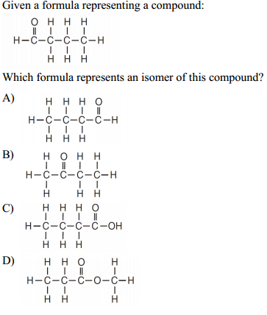
_____24. Given a structural formula, I can use Reference Table R to identify to which class of organic compounds a substance belongs. | 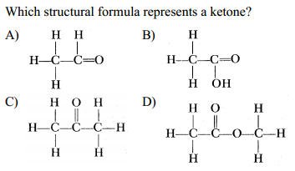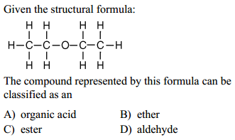  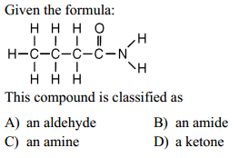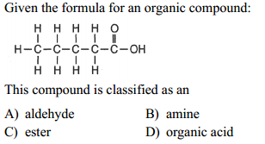
_____25. I can use Reference Tables P & Q and IUPAC nomenclature to name simple hydrocarbons. | Name the following hydrocarbons.  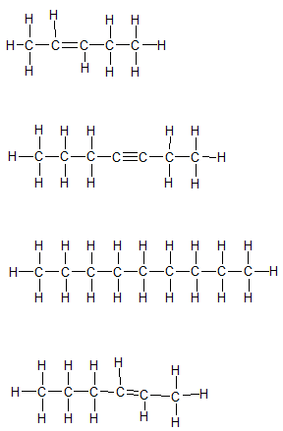
_____26. I can use Reference Tables P & R and IUPAC nomenclature to name simple compounds in any of the classes of organic compounds. | Name the following organic compounds.  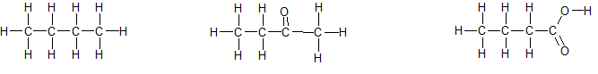  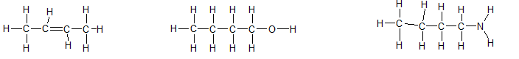  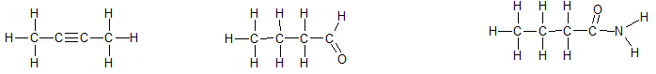  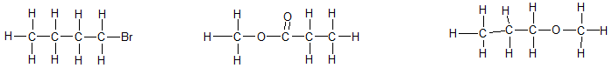
_____27. I can use F-SCAPES to list and describe the 7 types of organic reactions. | F stands for_______________________________. This type of organic  reaction results from a reaction of _____________________ to form  _________________________________ and ________________________. It typically requires a catalyst, in the form of an enzyme to occur.  S stands for _______________________________. This type of organic  reaction happens when _____________________________ hydrocarbons  replace one of the _____________________ for some other element (often a halide).  C stands for _______________________________. In this type of organic  reaction a ____________________________________ reacts with  ___________________ to form ___________________________ and  _______________________. It is an exothermic reaction.  A stands for ____________________________. In this type of organic reaction  an _______________________________________ becomes a  __________________________________________ when the double bond breaks and two atoms of another element (often a halide) are added.
_____27. I can use F-SCAPES to list and describe the 7 types of organic reactions. (continued) | P stands for __________________________________. In this type of organic  reaction many __________________ are linked together to form a  __________________________. A generalized form of this reaction looks like this…..  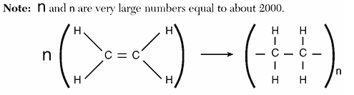  E stands for _________________________________. In this type of organic  reaction an ______________________ reacts with a  ________________________________ to form an ___________________ and  ___________________________. The products of this reaction are typically fragrant.  S stands for __________________________________. In this type of organic  reaction a ____________ reacts with a ____________________ to form  ______________________. You can really “clean up” if you remember this organic reaction.
_____28. Given an equation, I can identify the type of organic reaction that is occurring. | 