Name_____________________________ Unit 13: Nuclear Chemistry
I Can Statements
_____5. I can compare types of radiation in terms of symbol, mass number, charge, penetrating power, shielding required, and biological hazard. | Type Symbol Mass # Charge Penetrating Power Shielding Required Bio Hazard  alpha  beta  gamma  neutron  positron
_____6. I can identify the three types of nuclear reactions. | The three types of nuclear reactions are:  a.  b.  c.
_____7. I can define transmutation, fission, and fusion. | Definitions:  transmutation  fission  fusion
_____8. I can state two synonyms for spontaneous decay. | Two synonyms for spontaneous decay are:___________________________  and _________________________________.
_____9. I can show how mass number and electrical charge must be conserved in any nuclear reaction. | Complete the following nuclear equation:  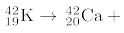________
_____10. I can explain what makes a nucleus stable or unstable. | The stability of the nucleus is dependent on the ______________ to  _________________ ratio.
_____11. I can explain the difference between natural transmutation and artificial transmutation. | The difference between natural transmutation and artificial transmutation is that in natural transmutation an_____________ __________breaks apart on its own and in artificial transmutation a _____________ ___________ is made ________________ by hitting it with a high energy particle (such as a proton, neutron, or gamma radiation).
_____12. I can identify a natural decay reaction from a list of reactions. | Which equation represents a natural decay?  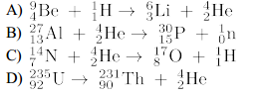
_____13. I can identify an artificial transmutation reaction from a list of reactions. | Which equation represents artificial transmutation?  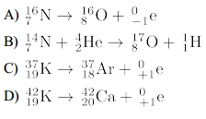
_____14. I can identify a fission reaction from a list of reactions. | Which equation represents fission?  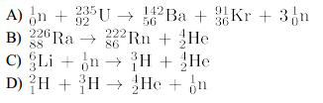
_____15. I can identify a fusion reaction from a list of reactions. | Which equation represents fusion?
_____16. I can state the conditions of temperature and pressure that are needed for a fusion reaction to happen. | The temperature and pressure conditions needed for fusion to happen are:  ____________ temperature and _______________ pressure
_____17. I can explain why all nuclear reactions release LOTS more energy than chemical reactions do. | Nuclear reactions release LOTS more energy than chemical reactions do because
_____18. Given a list of reactions, I can differentiate a “nuclear” reaction from a “chemical” reaction. | Which of the following equations represent NUCLEAR reactions?  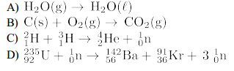
_____19. I can define half-life. | Definition:  half-life
_____20. Given the length of the half-life and the amount of time that has passed, I can determine the amount of radioactive sample. | Based on Reference Table N, what fraction of a radioactive sample of Au-198 will remain unchanged after 10.78 days?  What was the original mass of a radioactive sample of K-37 if the sample decayed to 25.0 g after 4.92 seconds? The half-life of K-37 is 1.23 seconds)
_____21. Given the length of the half-life and the amount of radioactive sample, I can determine the amount of time that has passed. | A 100.0 g sample of Co-60 decays until only 12.5 g of it remains. Given that the half-life of Co-60 is 5.271 years, how long did the decay take?
_____22. Given the amount of time that has passed and the amount of radioactive sample, I can determine the length of the half-life. | What is the half-life of a radioisotope if 25.0 g of an original 200.0 g sample remains unchanged after 11.46 days?
_____23. Using Table N, I can determine the length of half-life and/or decay mode for a specific radioactive isotope. | Compared to K-37, the isotope K-42 has  A) shorter half-life and the same decay mode  B) shorter half-life and a different decay mode  C) longer half-life and the same decay mode  D) longer half-life and a different decay mode
_____24. I can state 5 beneficial uses for radioactive isotopes. | Five beneficial uses for radioactive isotopes are:  a.  b.  c.  d.  e.
_____25. I can state the scientific use of 4 specific radioactive isotopes. | C-14 is used for _____________________________________________  I-131 is used for_____________________________________________  U-238 is used for ____________________________________________  Co-60 is used for_____________________________________________
_____26. I can state three risks associated with radioactivity and radioactive isotopes. | Three risks associated with radioactivity and radioactive isotopes are:  a.  b.  c.

